VISVESVARAYA TECHNOLOGICAL UNIVERSITY BELAGAVI- 590018

BLDEA’S V.P. DR.P.G.HALAKATTI COLLEGE OF ENGINEERING AND TECHNOLOGY, VIJAYAPUR 586103



DEPARTMENT OF COMPUTER SCIENCE AND

ENGINEERING

A MINI PROJECT REPORT ON

“BILLING SYSTEM”

UNDER THE GUIDANCE OF

Prof.Santosh Chinchali

-: SUBMITTED BY:-

1. NIKHIL GUGAWAD(2BL19CS057)
2. SHREEHARI HULYALKAR(2BL19CS088)
3. SHUBHAMSING THAKUR(2BL20CS407)

VISVESVARAYA TECHNOLOGICAL UNIVERSITY BELAGAVI-590018

BLDEA’S V.P. DR.P.G.HALAKATTI COLLEGE OF ENGINEERING AND TECHNOLOGY, VIJAYAPURA 586103



DEPARTMENT OF COMPUTER SCIENCE AND

ENGINEERING

-:Certificate:-

This is to certify that the mini project in User Interface Design [18CS734] work entitled “BILLING SYSTEM” Carried out by NIKHIL GUGWAD(2BL19CS057), SHREEHARI HULYALKAR(2BL19CS088),

SHUBHAMSING THAKUR(2BL20CS407). The mini project report has been approved as it satisfies the academic requirements in respect of project work prescribed for Bachelor of Engineering Degree in Computer Science & Engineering.

GUIDE HOD PRINCIPAL

# Mr.Santosh Chinchali Dr.Pushpa B. Patil Dr.V.G. Sangam

**ACKNOWLEDGEMENT**

We would like to express deep sense of gratitude to our beloved principal **Dr. V. G. Sangam** providing all facilities in the college.

We would like to thank wholeheartedly to our Head of Department **Dr. PUSHPA PATIL** for providing facilities and fostering congenial academicenvironment in the college.

We feel deeply indebted to our esteemed project guides **Prof. SANTOSH CHINCHALI** for their impact fully help right from theconception and visualization to the very presentation of the mini project on UID. They have been our guiding light.

We would take this opportunity to thank all the faculty members and supporting staff for helping us in this endeavor.

Last but not the least we would like to thank our parents, all my friends and well- wishers who have helped us.

**Project Associates**

1. Nikhil Gugawad
2. Shreehari Hulyalkar
3. Shubhamsing Thakur

**ABSTRACT**

Paperless billing is a process that businesses can use to get paid quickly and securely without dealing with the hassles of paper bills and check payments.Paperless bills allow bill delivery and payments to take place completely online,which improves efficiency while reducing costs.

Paperless Billing generally involves integrating multiple systems. These include billing system, the banking industry, customer’s paying system, as well as an online interface for the paperless billing system. Paperless billing is most helpful for businesses that send recurring bills to customers. Paperless bills are an option for delivering bills. Bills could be presented as electric documents, such as PDF, or on websites. This gives the customer the ability to review bills before sending payment. Alternately, customers can also set up automated payments in

order to pay without even touching a button. We can shop and create bills by using the mobile application.

Paperless Bills offer benefits to both the seller as well as the customer. Some of the biggest benefits from Paperless

Billing include:

• Low cost of delivering the bills to customers

• Better security than paper and snail mail

• Option for automatic storage of bill

INDEX

**S.NO** **TOPICS** **PAGE NO**

1 Introduction 6

2 Objectives 7

3 Technology used 8

4 Implementation 9 - 16

6 Output Screenshots 17

7 Conclusion 18

8 Reference 19

INTRODUCTION

This Bill Management System is in Python. Talking about the features of this system, it contains only the admin section. The admin manages all the orders management, payments, and report. Here, GUI is created using Python Tkinter. Here, the user can enter customer details and select items from the menu. The software displays the menu items as category wise. Users can generate bills after selecting at least 1 item. The system displays a bill inside the ‘Bill Area’ section.

OBJECTIVES

* Customer, Products, Billing Generation: Automate the current manual bill generation system and maintain the searchable customer, products database and product invoice, maintain the data security, user rights.
* To develop a system for the management of sales, Purchase and stock maintenance processes that will be performed with a click of mouse button.➢
* To develop a system that has a good management of data along with integrity and minimizing redundancy.➢
* To develop a system that will be user friendly in all possible ways.➢
* To develop a system that provides easier work than existing system for the user.➢
* To develop a secure system that can be accessed only by authorized users.

TECHNOLOGIES USED

* **Python3:-** It is High-level, general-purpose programming language. Its design philosophy emphasizes code readability with the use of significant indentation. It is a dynamically-typed and garbage-collected. It supports multiple programming paradigms, including structured, object-oriented and functional programming. It is designed by **Guido van Rossum** in 20 Feb 1991. It is available for Windows, mac OS, Linux/UNIX, Android and more. It follows Camel Case or snake case convention. A python file can be created or identified using **.py** extension at the end of filename.
* **Tkinter module:-** It is the standard GUI library for python. Python when combined with Tkinter provides a fast and easy way to create GUI applications. Tkinter provides a powerful object-oriented interface to the Tk GUI toolkit. To use the Tkinter module in the program, we need to import it first as, **import Tkinter as tk**.

IMPLEMENTATION

**Source code:**

from tkinter import *

import random

import os

import sys

from tkinter import messagebox

class Bill_App:

    def __init__(self,root):

        self.root=root

        self.root.geometry("1350x700+0+0")

        self.root.configure(bg="#5B2C6F")

        self.root.title("Billing System")

        title=Label(self.root,text="Billing System",bd=12,relief=RIDGE,font=("Arial Black",20),bg="#A569BD",fg="white").pack(fill=X)

        #===================================variables=======================================================================================

        self.nutella=IntVar()

        self.noodles=IntVar()

        self.lays=IntVar()

        self.oreo=IntVar()

        self.muffin=IntVar()

        self.silk=IntVar()

        self.namkeen=IntVar()

        self.atta=IntVar()

        self.pasta=IntVar()

        self.rice=IntVar()

        self.oil=IntVar()

        self.sugar=IntVar()

        self.dal=IntVar()

        self.tea=IntVar()

        self.soap=IntVar()

        self.shampoo=IntVar()

        self.lotion=IntVar()

        self.cream=IntVar()

        self.foam=IntVar()

        self.mask=IntVar()

        self.sanitizer=IntVar()

        self.total_sna=StringVar()

        self.total_gro=StringVar()

        self.total_hyg=StringVar()

        self.a=StringVar()

        self.b=StringVar()

        self.c=StringVar()

        self.c_name=StringVar()

        self.bill_no=StringVar()

        x=random.randint(1000,9999)

        self.bill_no.set(str(x))

        self.phone=StringVar()

        #==========================================customer details label frame=================================================

        details=LabelFrame(self.root,text="Customer Details",font=("Arial Black",12),bg="#A569BD",fg="white",relief=GROOVE,bd=10)

        details.place(x=0,y=80,relwidth=1)

        cust_name=Label(details,text="Customer Name",font=("Arial Black",14),bg="#A569BD",fg="white").grid(row=0,column=0,padx=15)

        cust_entry=Entry(details,borderwidth=4,width=30,textvariable=self.c_name).grid(row=0,column=1,padx=8)

        contact_name=Label(details,text="Contact No.",font=("Arial Black",14),bg="#A569BD",fg="white").grid(row=0,column=2,padx=10)

        contact_entry=Entry(details,borderwidth=4,width=30,textvariable=self.phone).grid(row=0,column=3,padx=8)

        bill_name=Label(details,text="Bill.No.",font=("Arial Black",14),bg="#A569BD",fg="white").grid(row=0,column=4,padx=10)

        bill_entry=Entry(details,borderwidth=4,width=30,textvariable=self.bill_no).grid(row=0,column=5,padx=8)

        #=======================================snacks label frame=================================================================

        snacks=LabelFrame(self.root,text="Snacks",font=("Arial Black",12),bg="#E5B4F3",fg="#6C3483",relief=GROOVE,bd=10)

        snacks.place(x=5,y=180,height=380,width=325)

        item1=Label(snacks,text="Nutella Choco Spread",font=("Arial Black",11),bg="#E5B4F3",fg="#6C3483").grid(row=0,column=0,pady=11)

        item1_entry=Entry(snacks,borderwidth=2,width=15,textvariable=self.nutella).grid(row=0,column=1,padx=10)

        item2=Label(snacks,text="Noodles(1 Pack)",font=("Arial Black",11),bg="#E5B4F3",fg="#6C3483").grid(row=1,column=0,pady=11)

        item2_entry=Entry(snacks,borderwidth=2,width=15,textvariable=self.noodles).grid(row=1,column=1,padx=10)

      item3=Label(snacks,text="Lays(10Rs)",font=("Arial Black",11),bg="#E5B4F3",fg="#6C3483").grid(row=2,column=0,pady=11)

        item3_entry=Entry(snacks,borderwidth=2,width=15,textvariable=self.lays).grid(row=2,column=1,padx=10)

    item4=Label(snacks,text="Oreo(20Rs)",font=("Arial Black",11),bg="#E5B4F3",fg="#6C3483").grid(row=3,column=0,pady=11)

        item4_entry=Entry(snacks,borderwidth=2,width=15,textvariable=self.oreo).grid(row=3,column=1,padx=10)

  item5=Label(snacks,text="Chocolate Muffin",font=("Arial Black",11),bg="#E5B4F3",fg="#6C3483").grid(row=4,column=0,pady=11)

        item5_entry=Entry(snacks,borderwidth=2,width=15,textvariable=self.muffin).grid(row=4,column=1,padx=10)

item6=Label(snacks,text="Dairy Milk Silk(60Rs)",font=("Arial Black",11),bg="#E5B4F3",fg="#6C3483").grid(row=5,column=0,pady=11)

        item6_entry=Entry(snacks,borderwidth=2,width=15,textvariable=self.silk).grid(row=5,column=1,padx=10)

        item7=Label(snacks,text="Namkeen(15Rs)",font=("Arial Black",11),bg="#E5B4F3",fg="#6C3483").grid(row=6,column=0,pady=11)

        item7_entry=Entry(snacks,borderwidth=2,width=15,textvariable=self.namkeen).grid(row=6,column=1,padx=10)

        #===================================GROCERY=====================================================================================

        grocery=LabelFrame(self.root,text="Grocery",font=("Arial Black",12),relief=GROOVE,bd=10,bg="#E5B4F3",fg="#6C3483")

        grocery.place(x=340,y=180,height=380,width=325)

  item8=Label(grocery,text="Aashirvaad Atta(1kg)",font=("Arial Black",11),bg="#E5B4F3",fg="#6C3483").grid(row=0,column=0,pady=11)

        item8_entry=Entry(grocery,borderwidth=2,width=15,textvariable=self.atta).grid(row=0,column=1,padx=10)

  item9=Label(grocery,text="Pasta(1kg)",font=("Arial Black",11),bg="#E5B4F3",fg="#6C3483").grid(row=1,column=0,pady=11)   item9_entry=Entry(grocery,borderwidth=2,width=15,textvariable=self.pasta).grid(row=1,column=1,padx=10)

  item10=Label(grocery,text="Basmathi Rice(1kg)",font=("Arial Black",11),bg="#E5B4F3",fg="#6C3483").grid(row=2,column=0,pady=11)

        item10_entry=Entry(grocery,borderwidth=2,width=15,textvariable=self.rice).grid(row=2,column=1,padx=10)

  item11=Label(grocery,text="Sunflower Oil(1ltr)",font=("Arial Black",11),bg="#E5B4F3",fg="#6C3483").grid(row=3,column=0,pady=11)

        item11_entry=Entry(grocery,borderwidth=2,width=15,textvariable=self.oil).grid(row=3,column=1,padx=10)

  item12=Label(grocery,text="Refined Sugar(1kg)",font=("Arial Black",11),bg="#E5B4F3",fg="#6C3483").grid(row=4,column=0,pady=11)

        item12_entry=Entry(grocery,borderwidth=2,width=15,textvariable=self.sugar).grid(row=4,column=1,padx=10)

  item13=Label(grocery,text="Daal(1kg)",font=("Arial Black",11),bg="#E5B4F3",fg="#6C3483").grid(row=5,column=0,pady=11)

        item13_entry=Entry(grocery,borderwidth=2,width=15,textvariable=self.dal).grid(row=5,column=1,padx=10)

  item14=Label(grocery,text="Tea Powder(1kg)",font=("Arial Black",11),bg="#E5B4F3",fg="#6C3483").grid(row=6,column=0,pady=11)

        item14_entry=Entry(grocery,borderwidth=2,width=15,textvariable=self.tea).grid(row=6,column=1,padx=10)

        #========================================beauty and hygine===============================================================================

        hygine=LabelFrame(self.root,text="Beauty & Hygine",font=("Arial Black",12),relief=GROOVE,bd=10,bg="#E5B4F3",fg="#6C3483")

        hygine.place(x=677,y=180,height=380,width=325)

  item15=Label(hygine,text="Bathing Soap",font=("Arial Black",11),bg="#E5B4F3",fg="#6C3483").grid(row=0,column=0,pady=11)

        item15_entry=Entry(hygine,borderwidth=2,width=15,textvariable=self.soap).grid(row=0,column=1,padx=10)

  item16=Label(hygine,text="Shampoo(1ltr)",font=("Arial Black",11),bg="#E5B4F3",fg="#6C3483").grid(row=1,column=0,pady=11)

        item16_entry=Entry(hygine,borderwidth=2,width=15,textvariable=self.shampoo).grid(row=1,column=1,padx=10)

  item17=Label(hygine,text="Body Lotion(1ltr)",font=("Arial Black",11),bg="#E5B4F3",fg="#6C3483").grid(row=2,column=0,pady=11)

        item17_entry=Entry(hygine,borderwidth=2,width=15,textvariable=self.lotion).grid(row=2,column=1,padx=10)

  item18=Label(hygine,text="Face Cream",font=("Arial Black",11),bg="#E5B4F3",fg="#6C3483").grid(row=3,column=0,pady=11)

        item18_entry=Entry(hygine,borderwidth=2,width=15,textvariable=self.cream).grid(row=3,column=1,padx=10)

  item19=Label(hygine,text="Shaving Foam",font=("Arial Black",11),bg="#E5B4F3",fg="#6C3483").grid(row=4,column=0,pady=11)

        item19_entry=Entry(hygine,borderwidth=2,width=15,textvariable=self.foam).grid(row=4,column=1,padx=10)

item20=Label(hygine,text="Face Mask(1piece)",font=("Arial Black",11),bg="#E5B4F3",fg="#6C3483").grid(row=5,column=0,pady=11)

        item20_entry=Entry(hygine,borderwidth=2,width=15,textvariable=self.mask).grid(row=5,column=1,padx=10)

item21=Label(hygine,text="Hand Sanitizer(50ml)",font=("Arial Black",11),bg="#E5B4F3",fg="#6C3483").grid(row=6,column=0,pady=11)

        item21_entry=Entry(hygine,borderwidth=2,width=15,textvariable=self.sanitizer).grid(row=6,column=1,padx=10)

        #=====================================================billarea==============================================================================

        billarea=Frame(self.root,bd=10,relief=GROOVE,bg="#E5B4F3")

        billarea.place(x=1010,y=188,width=330,height=372)

        bill_title=Label(billarea,text="Bill Area",font=("Arial Black",17),bd=7,relief=GROOVE,bg="#E5B4F3",fg="#6C3483").pack(fill=X)

        scrol_y=Scrollbar(billarea,orient=VERTICAL)

        self.txtarea=Text(billarea,yscrollcommand=scrol_y.set)

        scrol_y.pack(side=RIGHT,fill=Y)

        scrol_y.config(command=self.txtarea.yview)

        self.txtarea.pack(fill=BOTH,expand=1)

        #=================================================billing menu=========================================================================================

        billing_menu=LabelFrame(self.root,text="Billing Summery",font=("Arial Black",12),relief=GROOVE,bd=10,bg="#A569BD",fg="white")

        billing_menu.place(x=0,y=560,relwidth=1,height=137)

        total_snacks=Label(billing_menu,text="Total Snacks Price",font=("Arial Black",11),bg="#A569BD",fg="white").grid(row=0,column=0)

        total_snacks_entry=Entry(billing_menu,width=30,borderwidth=2,textvariable=self.total_sna).grid(row=0,column=1,padx=10,pady=7)

        total_grocery=Label(billing_menu,text="Total Grocery Price",font=("Arial Black",11),bg="#A569BD",fg="white").grid(row=1,column=0)

        total_grocery_entry=Entry(billing_menu,width=30,borderwidth=2,textvariable=self.total_gro).grid(row=1,column=1,padx=10,pady=7)

total_hygine=Label(billing_menu,text="Total Beauty & Hygine Price",font=("Arial Black",11),bg="#A569BD",fg="white").grid(row=2,column=0)

        total_hygine_entry=Entry(billing_menu,width=30,borderwidth=2,textvariable=self.total_hyg).grid(row=2,column=1,padx=10,pady=7)

  tax_snacks=Label(billing_menu,text="Snacks Tax",font=("Arial Black",11),bg="#A569BD",fg="white").grid(row=0,column=2)

        tax_snacks_entry=Entry(billing_menu,width=30,borderwidth=2,textvariable=self.a).grid(row=0,column=3,padx=10,pady=7)

        tax_grocery=Label(billing_menu,text="Grocery Tax",font=("Arial Black",11),bg="#A569BD",fg="white").grid(row=1,column=2)

        tax_grocery_entry=Entry(billing_menu,width=30,borderwidth=2,textvariable=self.b).grid(row=1,column=3,padx=10,pady=7)

tax_hygine=Label(billing_menu,text="Beauty & Hygine Tax",font=("Arial Black",11),bg="#A569BD",fg="white").grid(row=2,column=2)

        tax_hygine_entry=Entry(billing_menu,width=30,borderwidth=2,textvariable=self.c).grid(row=2,column=3,padx=10,pady=7)

button_frame=Frame(billing_menu,bd=7,relief=GROOVE,bg="#6C3483")

        button_frame.place(x=830,width=500,height=95)

        button_total=Button(button_frame,text="Total Bill",font=("Arial Black",15),pady=10,bg="#E5B4F3",fg="#6C3483",command=lambda:total(self)).grid(row=0,column=0,padx=12)

        button_clear=Button(button_frame,text="Clear Field",font=("Arial Black",15),pady=10,bg="#E5B4F3",fg="#6C3483",command=lambda:clear(self)).grid(row=0,column=1,padx=10,pady=6)

        button_exit=Button(button_frame,text="Exit",font=("Arial Black",15),pady=10,bg="#E5B4F3",fg="#6C3483",width=8,command=lambda:exit1(self)).grid(row=0,column=2,padx=10,pady=6)

        intro(self)

def total(self):

    if (self.c_name.get=="" or self.phone.get()==""):

        messagebox.showerror("Error", "Fill the complete Customer Details!!")

    self.nu=self.nutella.get()*120

    self.no=self.noodles.get()*40

    self.la=self.lays.get()*10

    self.ore=self.oreo.get()*20

    self.mu=self.muffin.get()*30

    self.si=self.silk.get()*60

    self.na=self.namkeen.get()*15

    total_snacks_price=(

                self.nu+

                self.no+

                self.la+

                self.ore+

                self.mu+

                self.si+

                self.na)

    self.total_sna.set(str(total_snacks_price)+" Rs")

self.a.set(str(round(total_snacks_price*0.05,3))+" Rs")

self.at=self.atta.get()*42

    self.pa=self.pasta.get()*120

    self.oi=self.oil.get()*113

    self.ri=self.rice.get()*160

    self.su=self.sugar.get()*55

    self.te=self.tea.get()*480

    self.da=self.dal.get()*76

    total_grocery_price=(

        self.at+

        self.pa+

        self.oi+

        self.ri+

        self.su+

        self.te+

        self.da)

    self.total_gro.set(str(total_grocery_price)+" Rs")

    self.b.set(str(round(total_grocery_price*0.01,3))+" Rs")

self.so=self.soap.get()*30

    self.sh=self.shampoo.get()*180

    self.cr=self.cream.get()*130

    self.lo=self.lotion.get()*500

    self.fo=self.foam.get()*85

    self.ma=self.mask.get()*100

    self.sa=self.sanitizer.get()*20

    total_hygine_price=(

        self.so+

        self.sh+

        self.cr+

        self.lo+

        self.fo+

        self.ma+

        self.sa)

    self.total_hyg.set(str(total_hygine_price)+" Rs")

    self.c.set(str(round(total_hygine_price*0.10,3))+" Rs")

    self.total_all_bill=(total_snacks_price+

                total_grocery_price+

                total_hygine_price+

                (round(total_grocery_price*0.01,3))+

                (round(total_hygine_price*0.10,3))+

                (round(total_snacks_price*0.05,3)))

    self.total_all_bil=str(self.total_all_bill)+" Rs"

    billarea(self)

def intro(self):

    self.txtarea.delete(1.0,END)

    self.txtarea.insert(END,"\tWELCOME TO SUPER MARKET\n\tPhone-No.739275410")

    self.txtarea.insert(END,f"\n\nBill no. : {self.bill_no.get()}")

    self.txtarea.insert(END,f"\nCustomer Name : {self.c_name.get()}")

    self.txtarea.insert(END,f"\nPhone No. : {self.phone.get()}")

    self.txtarea.insert(END,"\n====================================\n")

    self.txtarea.insert(END,"\nProduct\t\tQty\tPrice\n")

    self.txtarea.insert(END,"\n====================================\n")

def billarea(self):

    intro(self)

    if self.nutella.get()!=0:

        self.txtarea.insert(END,f"Nutella\t\t {self.nutella.get()}\t{self.nu}\n")

    if self.noodles.get()!=0:

        self.txtarea.insert(END,f"Noodles\t\t {self.noodles.get()}\t{self.no}\n")

    if self.lays.get()!=0:

        self.txtarea.insert(END,f"Lays\t\t {self.lays.get()}\t{self.la}\n")

    if self.oreo.get()!=0:

        self.txtarea.insert(END,f"Oreo\t\t {self.oreo.get()}\t{self.ore}\n")

    if self.muffin.get()!=0:

        self.txtarea.insert(END,f"Muffins\t\t {self.muffin.get()}\t{self.mu}\n")

    if self.silk.get()!=0:

        self.txtarea.insert(END,f"Silk\t\t {self.silk.get()}\t{self.si}\n")

    if self.namkeen.get()!=0:

        self.txtarea.insert(END,f"Namkeen\t\t {self.namkeen.get()}\t{self.na}\n")

    if self.atta.get()!=0:

        self.txtarea.insert(END,f"Atta\t\t {self.atta.get()}\t{self.at}\n")

    if self.pasta.get()!=0:

        self.txtarea.insert(END,f"Pasta\t\t {self.pasta.get()}\t{self.pa}\n")

    if self.rice.get()!=0:

        self.txtarea.insert(END,f"Rice\t\t {self.rice.get()}\t{self.ri}\n")

    if self.oil.get()!=0:

        self.txtarea.insert(END,f"Oil\t\t {self.oil.get()}\t{self.oi}\n")

    if self.sugar.get()!=0:

        self.txtarea.insert(END,f"Sugar\t\t {self.sugar.get()}\t{self.su}\n")

    if self.dal.get()!=0:

        self.txtarea.insert(END,f"Daal\t\t {self.dal.get()}\t{self.da}\n")

    if self.tea.get()!=0:

        self.txtarea.insert(END,f"Tea\t\t {self.tea.get()}\t{self.te}\n")

    if self.soap.get()!=0:

        self.txtarea.insert(END,f"Soap\t\t {self.soap.get()}\t{self.so}\n")

    if self.shampoo.get()!=0:

        self.txtarea.insert(END,f"Shampoo\t\t {self.shampoo.get()}\t{self.sh}\n")

    if self.lotion.get()!=0:

        self.txtarea.insert(END,f"Lotion\t\t {self.lotion.get()}\t{self.lo}\n")

    if self.cream.get()!=0:

        self.txtarea.insert(END,f"Cream\t\t {self.cream.get()}\t{self.cr}\n")

    if self.foam.get()!=0:

        self.txtarea.insert(END,f"Foam\t\t {self.foam.get()}\t{self.fo}\n")

    if self.mask.get()!=0:

        self.txtarea.insert(END,f"Mask\t\t {self.mask.get()}\t{self.ma}\n")

    if self.sanitizer.get()!=0:

        self.txtarea.insert(END,f"Sanitizer\t\t {self.sanitizer.get()}\t{self.sa}\n")

    self.txtarea.insert(END,f"------------------------------------\n")

    if self.a.get()!="0.0 Rs":

        self.txtarea.insert(END,f"Total Snacks Tax : {self.a.get()}\n")

    if self.b.get()!="0.0 Rs":

        self.txtarea.insert(END,f"Total Grocery Tax : {self.b.get()}\n")

    if self.c.get()!="0.0 Rs":

        self.txtarea.insert(END,f"Total Beauty&Hygine Tax : {self.c.get()}\n")

    self.txtarea.insert(END,f"Total Bill Amount : {self.total_all_bil}\n")

    self.txtarea.insert(END,f"------------------------------------\n")

def clear(self):

        self.txtarea.delete(1.0,END)

        self.nutella.set(0)

        self.noodles.set(0)

        self.lays.set(0)

        self.oreo.set(0)

        self.muffin.set(0)

        self.silk.set(0)

        self.namkeen.set(0)

        self.atta.set(0)

        self.pasta.set(0)

        self.rice.set(0)

        self.oil.set(0)

        self.sugar.set(0)

        self.dal.set(0)

        self.tea.set(0)

        self.soap.set(0)

        self.shampoo.set(0)

        self.lotion.set(0)

        self.cream.set(0)

        self.foam.set(0)

        self.mask.set(0)

        self.sanitizer.set(0)

        self.total_sna.set(0)

        self.total_gro.set(0)

        self.total_hyg.set(0)

        self.a.set(0)

        self.b.set(0)

        self.c.set(0)

        self.c_name.set(0)

        self.bill_no.set(0)

        self.bill_no.set(0)

        self.phone.set(0)

def exit1(self):

    self.root.destroy()

root=Tk()

obj=Bill_App(root)

root.mainloop()

OUTPUT SCREENSHOTS

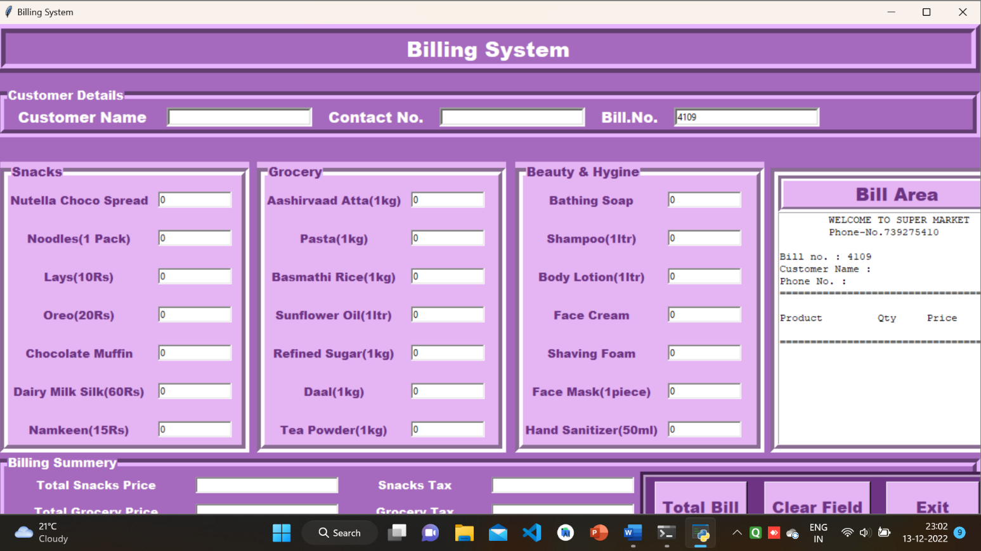

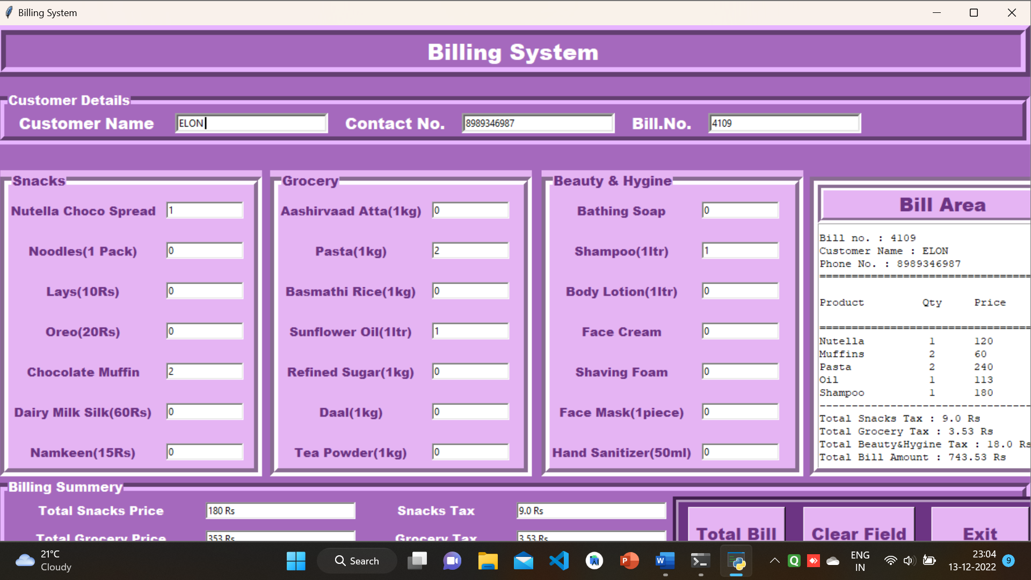

CONCLUSION

This project was about improving the existing billing system by making it digitized. A better way of billing system was implemented. Instead of a printed bill, the customer obtained a digital copy of it, which reduced

the wastage of paper. This also helped the seller to save the cost of buying paper. The bill was first stored in the seller’s system in an organized manner.

REFERENCE

* We are doing this project by referring informations from

https://code-projects.org

* We have used Visual Studio Code software to implement and to run the project.
* Visual Studio Code download link, <https://code.visualstudio.com/download>